PHOTORESPIRATION (C2 CYCLE) AND ITS SIGNIFICANCE
The respiration that occurs only in light in green cells and responsible for the release of extra CO2 is called photorespiration. Ribulose biphosphate carboxylase (RUBISCO) which is the main enzyme of photosynthesis also catalyses another reaction which interferes with the successful functioning of the Calvin cycle (C3). In presence of high concentration of O2, RUBISCO enzyme acts as oxygenase and converts Ribulose biphosphate to a 3 carbon compound-Phosphoglyceric acid (PGA) and a 2 carbon compound-Phosphoglycolic acid which undergoes further reactions and releasing CO2 only in presence of high concentrations of O2. This release of CO2 in presence of high concentration of O2 in light by green cells is called Photorespiration and was given by Decker. No energy is released and cell organelles involved are Chloroplast, Peroxisomes and Mitochondria.
Photorespiration is called C2 cycle or Glycolic acid cycle. It mostly occurs in C3 plants.
SIGNIFICANCE OF PHOTORESPIRATION:
- Photorespiration helps in dissipation of energy where stomata get closed during day time because of water stress.
- Photorespiration (C2 cycle) functions as carbon scavenging mechanism because it returns to the C3 cycle three quarters of the carbon that could have been as glycolate. Thus supports that photorespiration is a normal component of photosynthetic metabolism and is dependent on the C3 pathway.
MAIN REACTIONS INVOLVED IN PHOTORESPIRATION ARE:
- RBP combines with O2 and forms one molecule each of 3-Phosphoglyceric acid (PGA) and a 2 -Phosphoglycolic acid in presence of the enzyme.
- 2-Phosphoglycolic acid loses its phosphate and converted into glycolic acid.
- Glycolic acid from the chloroplast is transported to the peroxisome where it reacts with O2 to form Glyoxylic acid H2O in presence of enzyme Glycolic acid-oxidase.
- The Glyoxylic acid is converted to an amino acid-Glycine by transamination reaction in presence of enzyme Glutamate-Glyoxylate transaminase.
- Glycine is transported to the mitochondria where 2 molecules of glycine interact to form one molecule each of serine, CO2 and NH3-. The CO2 is released from the mitochondria. NH3 released is used in the synthesis of Glutamic acid.
- The amino acid serine is transported back to peroxisome where it is deaminated and reduced to hydroxy-pyruvic acid and finally to glyceric acid.
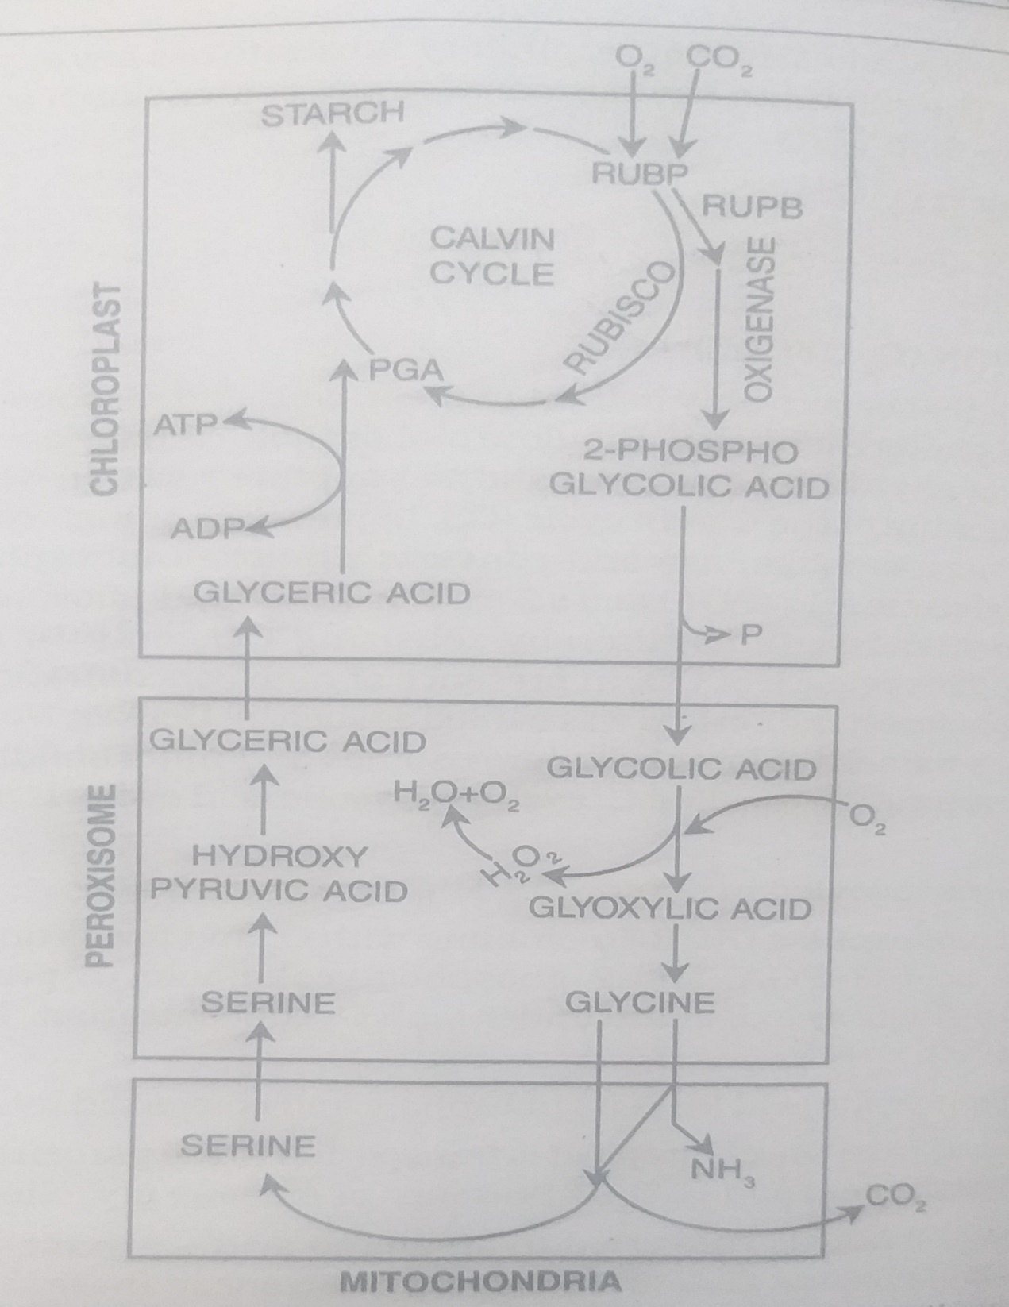
BIOCHEMICAL PATHWAY OF PHOTORESPIRATION

DIFFERENCES BETWEEN C3 AND C4 PLANTS
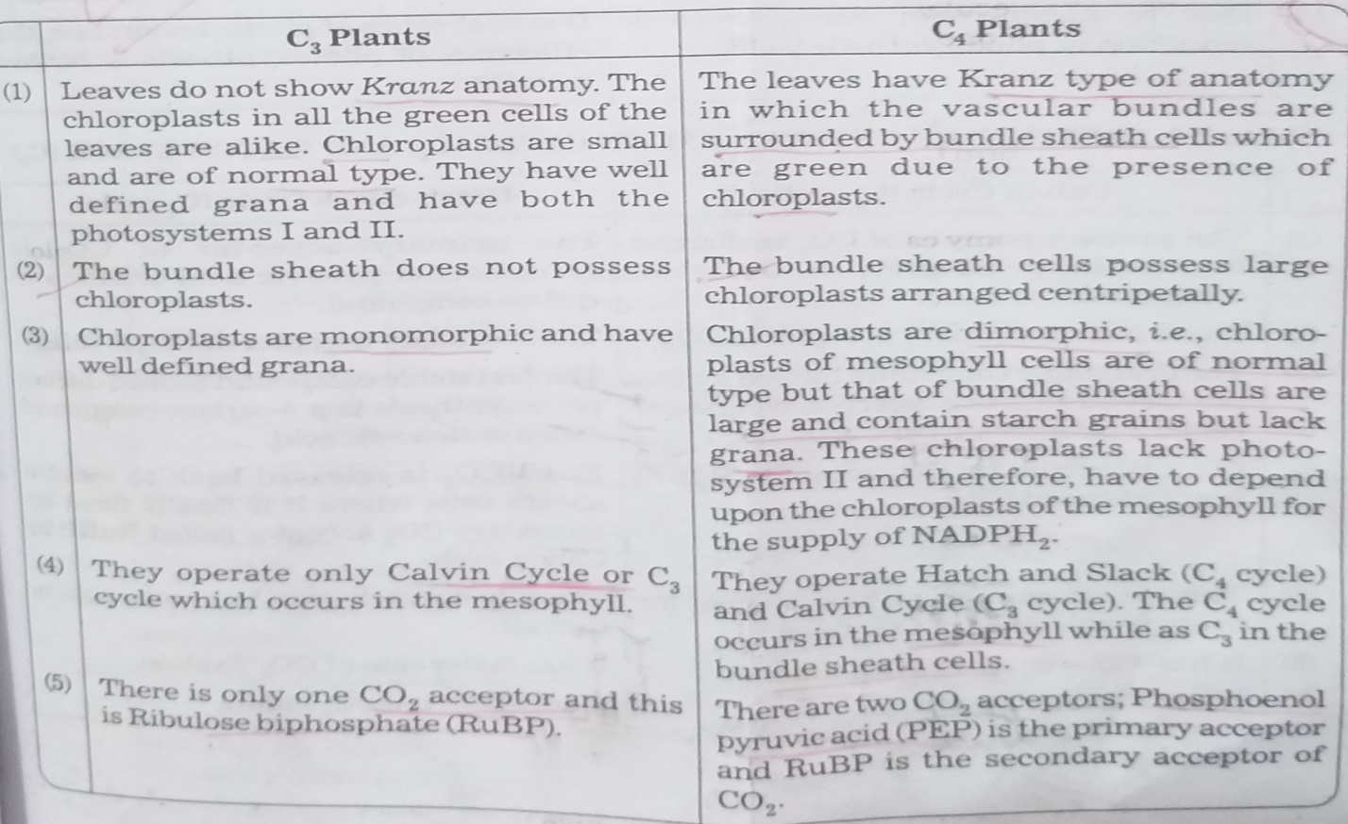
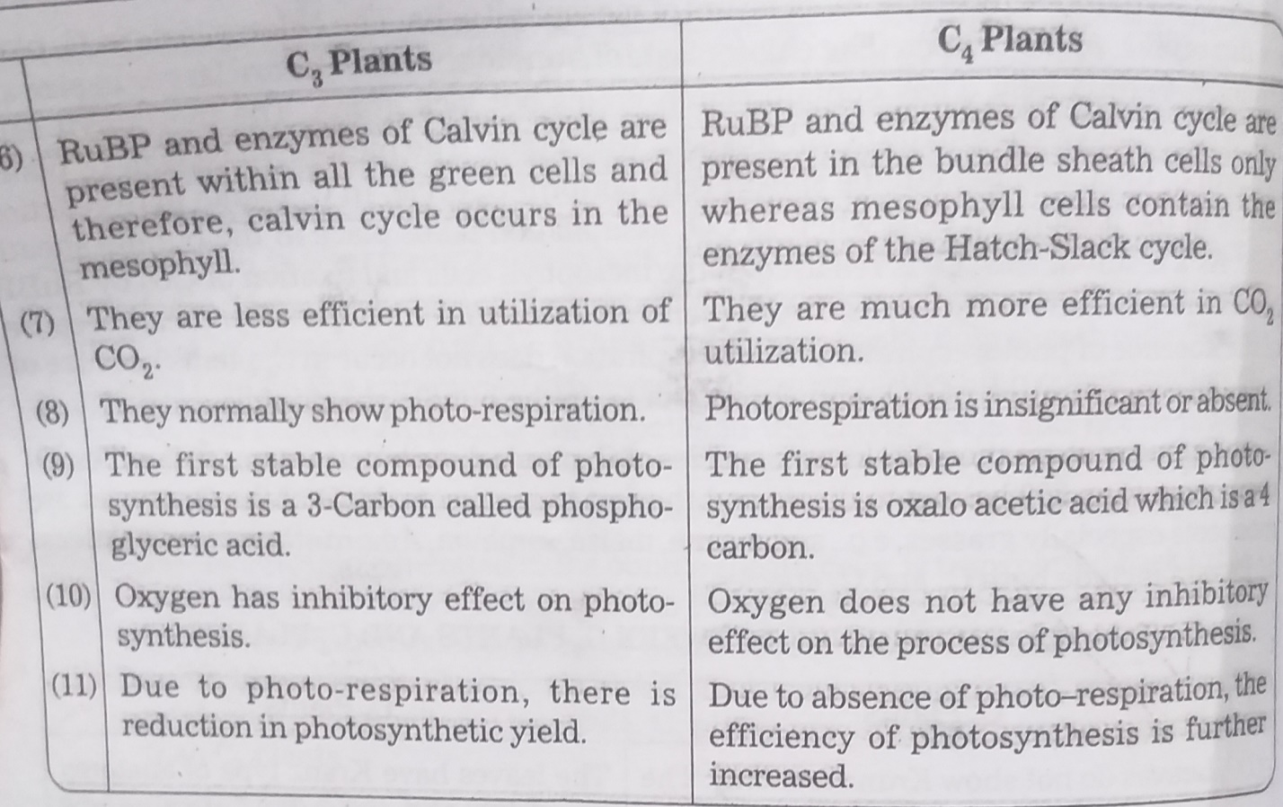

DIFFERENCES BETWEEN C3 AND C4 CYCLE
