PHYTOCHROME: RED AND FAR RED RESPONSES ON PHOTOMORPHOGENESIS
PHYTOCHROME
Phytochrome is a light sensitive protein pigment which absorbs light (red and far red) and is involved in several plant activities. For plants, the sensing of light in the environment is as important as vision is for animals. In one way plants sense light through the phytochromes, a small family of diverse photochromic protein photoreceptors.
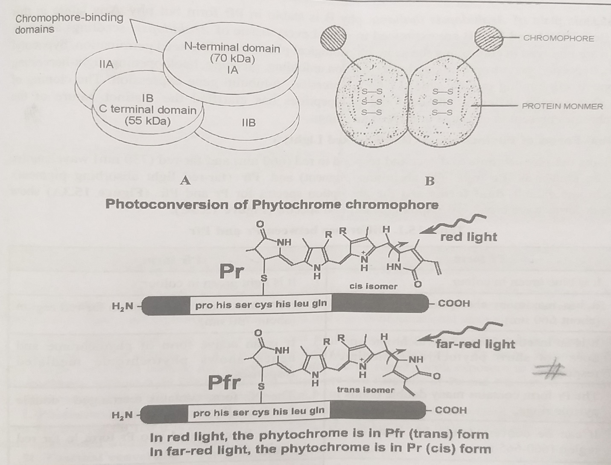
PHYTOCHROME A. DIAGRAMMATIC B. DIMER C. STRUCTURE

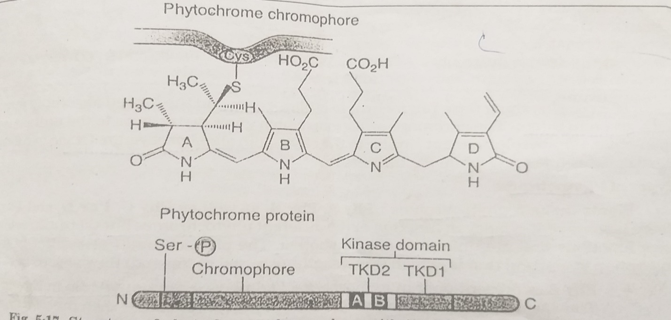STRUCTURE OF PHYTOCHROME CHROMOPHORE WITH ITS DIFFERENT FUNCTIONAL DOMAINS
Chemically phytochrome is a family of proteins with a small covalently-bound pigment molecule called chromophore. This chromophore is an open chain tetrapyrrole similar to the photosynthetic phycobilin pigment of the red algae and cyanobacteria. The chromophore absorbs the light that causes phytochrome responses.
The phytochrome exists in 2 forms Pr and Pfr and is interconversible i.e. changing color on photon absorption and of reverting to original on the absorption of another photon.
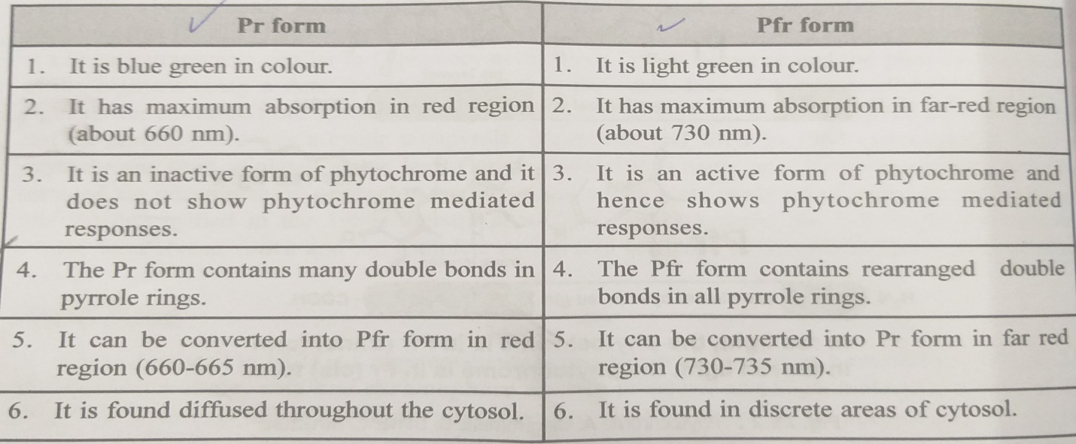
The Pr form of phytochrome absorbs red light up to maximum of 660nm while as Pfr form absorbs far red light at 730 nm. When Pr absorbs red light, it is converted to Pfr form which is the active form that initiates biological responses. When Pfr absorbs far red light, it is converted to Pr form which is inactive.
When the chromophore absorbs light, there is a slight change in its structure. This causes a change in the conformation of the protein portion to the form that initiates a response. Phytochrome levels are much higher (50%) in dark grown seedlings than in light grown plants. Its level is highest near the apex of the plant. When Pr is converted to Pfr by red light, conjugation of double bonds in the tetrapyrrole chromophore is altered; evidence indicates that the conjugated double bond system of Pfr has one less double bond than that of Pfr.
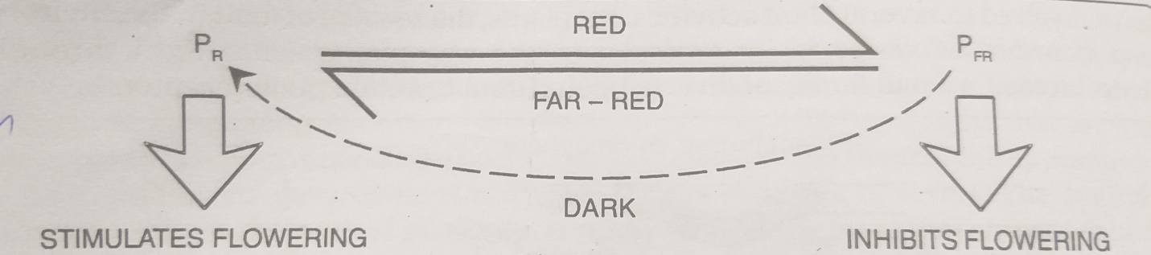
The red absorbing form phytochrome is blue green and the far red absorbing form is light green in color. The chromophoric group which gives two colors to the protein is an open chain tetrapyrrole pigment similar to the phycobilin-allophycocyanin. Of the 2 forms, Pr stimulates flowering while Pfr inhibits it.
TYPES: Plants make 5 phytochromes: Phy A, Phy B as well as Phy C, Phy D, Phy E.
Phy A | Phy B | Phy C | Phy D | Phy E
-Present only in angiosperms.  -Plays a promotive role in flowering.  -Phy A signaling may suppress the biosynthesis of a floral suppressor.  -Transgenic Arabidopsis overexpressing Phy A flower earlier than the wild type in both SD and Quasi-LD conditions. | -plays an inhibitory role in floral initiation. | -It is a low abundance member of the 5 membered phytochrome families of the photoreceptors in Arabidopsis.  - May have some physiological roles that are different to those of Phy A, Phy B in the control of seedling responses to light signals. | -Like Phy B, it also inhibits flowering. | -Phy E mutant Arabidopsis shows no phenotypic alteration unless it is in the Phy B mutant background.  -Plants containing mutations in both Phy B and Phy E genes have reduced suppression of floral initiation, so that they flower very early.

DISCOVERY OF PHYTOCHROME
Phytochrome discovery is closely related with studies on flowering. Although many other light controlled plant responses except photosynthesis, collectively known as Photo-Morphogenesis, are the effects of phytochrome action. Borthwick and Hendricks (1932) at the U.S Department of Agriculture, Beltsville showed that Red light (630 to 680 nm) bring out the germination of lettuce seeds, whereas Far red light (710 to 740 nm) inhibits the process. Hendricks and Parker (1952) reported that red light inhibition of flowering in Xanthium could be reversed by a subsequent far-red light treatment. The action spectra for inhibition and promotion of flowering show that the red light and far red light are effective. Borthwick and Hendrick concluded that Phytochrome as Photoreceptor exists in 2 inter convertible forms, one absorbing red radiation (Pr or P660), the other with an absorption maximum in the far red region of the spectrum (Pfr or P730). Butler and his associates firstly extracted phytochrome from etiolated oat coleoptiles and used the term phytochrome for this photo-reversible pigment. It occurs as a chromo-protein in which the chromophore is a linear tetra-pyrrole similar to C-Phycocyanin. Siegelman and Firir in 1964 extracted and purified phytochrome from etiolated maize leaf. Phytochrome was finally purified in the 1980s.Vierstra and Quail (1982) isolated the full length phytochrome protein from Avena sativa and the complete amino acid sequence of this phytochrome was obtained in 1985.
MECHANISM OF ACTION OF PHYTOCHROME
The mechanism by which the phytochrome photoreceptor family transduces informational light signals to photo responsive genes is still unclear in certain areas, although progress has been made. Phytochrome is believed to act in the following ways:
-Phytochrome-GFP fusion proteins migrate to the cell nucleus after they are activated by red light.
-Neither artificial nuclear translocation of non-photo activated phytochrome nor artificial retention of photo activated phytochrome in the cytosol provides detectable biological activity.
Phytochrome signaling to photo-regulated genes includes a direct pathway involving physical interaction between the photoreceptor and a transcriptional regulator.
-When sunlight (660nm) converts Pr into Pfr, the Pfr moves from the cytoplasm into the nucleus.
-There it binds to PIF3 (a phytochrome interacting factor necessary for normal photo-induced signal transduction is a novel basic helix-loop-helix DNA binding protein containing a PAS domain)
-The complex of the two binds to and turns on promoters containing the sequence.
CACGTC
CTGCAC G-BOX
-These promoters are found in genes that they encode other transcriptional factors.
-These other transcriptional factors, in turn, initiate transcription of a variety of genes that are expressed when the plant is exposed to light.
-Exposure to far red light converts the Pfr back to Pr which
- Dissociates from PIF3
- Returns to the cytoplasm.
The studies of the role of phytochrome indicate that Pfr is the active form and Pr is inactive form. Plants measure the ratio of Pfr/Pr. A long day plant would flower when the ratio is high (i.e. more Pfr) but SDP would flower when the ratio is low (more Pr). Since Pfr is labile and is broken down at night or reverts back to Pr-the longer the night, the lower the phytochrome (Pfr) content. Thus, phytochrome is like the sand in the egg timer; the relative amount of Pfr remaining at the end of the night would be an indication of the day length. Flowering timer would be rest during the day when Pfr levels are reestablished.
PHYSIOLOGICAL ROLES OF PHYTOCHROME
Phytochromes have been found to control a number of physiological responses of the plants:
- PHOTOPERIODISM
Following observations indicate that phytochrome is involved in the initiation of stimulus for flowering-
- Long dark periods of short day plants, if interrupted mid-way by a brief exposure of red light (660 mµ), the flowering is inhibited.
- If the exposure of red light is immediately followed by far red light (730 mµ), the flowering is promoted.
- Where flowering is promoted or inhibited depends on the exposure given in the last when 2 types of radiations (red and far red) given successively.
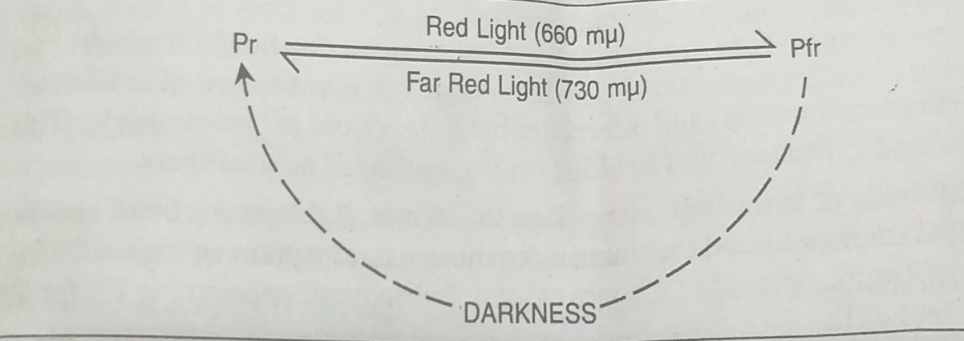
- PHYTOCHROME IN SHORT DAY PLANTS: At the end of light period most of the phytochrome is converted to Pfr from which inhibits flowering in short day plants. During long dark period Pfr form is converted to Pr form which promotes the formation of flowering stimulus. If the long dark period is interrupted with red light the Pr form is converted to Pfr form. This inhibits flowering stimulus.
- PHYTOCHROME IN LONG DAY PLANTS: Stimulus in these plants is promoted by Pfr form of Phytochrome. Long photoperiod favors conversion of Pr form to Pfr form. If dark period is longer, the Pfr form is converted to Pr form which inhibits the formation of flowering stimulus.
It is therefore concluded that flowering in short day plants is promoted by Pr form and inhibited by Pfr form whereas in long day plants flowering is promoted by Pfr form and inhibited by Pfr form.
- SEED GERMINATION
Germination of seeds in some plants is dependent on the photoperiodic stimulus. For example, germination of lettuce seeds requires a light stimulus and this is affected by red light and reversed by far red light.
- PIGMENTATION-ANTHOCYANIN SYNTHESIS
As early in 1913, Dugger suggested that anthocyanin or flavone pigments may be formed in response to sunlight. Later, in 1958, Siegelman and Hendricks found action spectrum for pigmentation of apples to indicate involvement of phytochrome.
- PIGMENTATION-CHLOROPHYLL SYNTHESIS
When etiolated seedlings are exposed to light, rapid chlorophyll synthesis takes place from proto-chlorophyll present in plants. This is followed by a lag phase and again by a rapid increase in chlorophyll synthesis. Red light has been found to eliminate the lag phase and FR can reverse the effect of R.

- PIGMENTATION IN CUTICLE
Tomato fruits is also phytochrome mediated.
- DE-ETIOLATION
Etiolation is the phenomenon exhibited by green plants when grown in darkness. Such plants are pale yellow due to absence of chlorophyll. Their stems are exceptionally long owing to abnormal lengthening of internodes and their leaves are reduced in size.
- INHIBITION OF INTERNODE ELONGATION IN NORMAL LIGHT-BROWN BEAN SEEDLINGS
Down et. al demonstrated that internodes showed no elongation if exposed to red for 5 min after a continuous period of 8 hours of light. Subsequent exposure to FR for 5 min reversed the effect of R.
- PLASTIDS
Development, differentiation and cleavage of plastids have also been found to be phytochrome controlled, as studied in etiolated leaves by Virgin. (1904)
- HYPOCOTYL-HOOK OPENING
Edwards and Klein reported that opening of hypocotyl hook in Phaseolus vulgare is induced by red light. Analysis of hook straightening has shown that red light induces opening of hook by triggering cell enlargement on the inner or concave side. Outer side cells do not contribute to hook opening. Auxin produced by hook tip mediates this phenomenon. Red light either reduces sensitivity of cells to synthesize auxin or lowers the level of endogenous auxin by enhancing translocation or by degradation.
- UNFOLDING OF LEAVES OF WHEAT SEEDLINGS
The degree of leaf unfolding in wheat seedlings depends on the length of the leaf segment irradiation. Intensity of light does not affect the degree of response. The substance formed in the segment of leaf as a result of phytochrome action, is motile and hence results in unfolding of the whole leaf.
- Other phytochrome mediated photo responses in plants include, sex expression, bud dormancy, leaf abscission, rhizome and bulb formation, epinasty, succulency, formation of leaf primordial, enlargement of cotyledons, change in the rate of respiration, increase in the protein and RNA synthesis, change in the rate of fat degradation and reserve protein degradation, auxin catabolism, permeability of cell membrane, differentiation of stomata etc.
- DEVELOPMENTAL RESPONSES IN LOWER PLANTS
Some of the developmental responses in plants other than angiosperms are as follows:
- Bud differentiation in protonema of Physcomitrium piriforme.
- Spore germination and gametophyte development in Sphaerocarpus dunnelli.
- Control of growth of gemmalings of Lunalaria cruciata.
- Rhizoid development from gemmae of Lunalaria cruciata.
- Elongation of protoema of fern, Onocdea serisibilts.
- Control of senescence in Marchantia thallus.
- Spore germination in the fern Cheilanthes.
Development responses are slow and there is always a lag phase between irradiation and observable or measurable response. Hence, it may involve activation or repression of genes or enzymes or phytochrome may regulate hormone metabolism.
PHOTOMORPHOGENESIS
Light is an important environmental factor controlling plant growth and development. A principal reason for this is that light causes photosynthesis. Furthermore, light influences development by causing phototropism. Numerous other effects of light that are quite independent of photosynthesis also occur; most of these effects control the appearance of the plant that is, its development or morphogenesis (origin of form). The control of morphogenesis by light is called Photomorphogenesis. One pigment that absorbs light (red and far red) effective in causing Photomorphogenesis has been identified and named phytochrome, but another pigment that absorbs violet and blue light, was named Cryptochrome because its chemical nature is unknown.
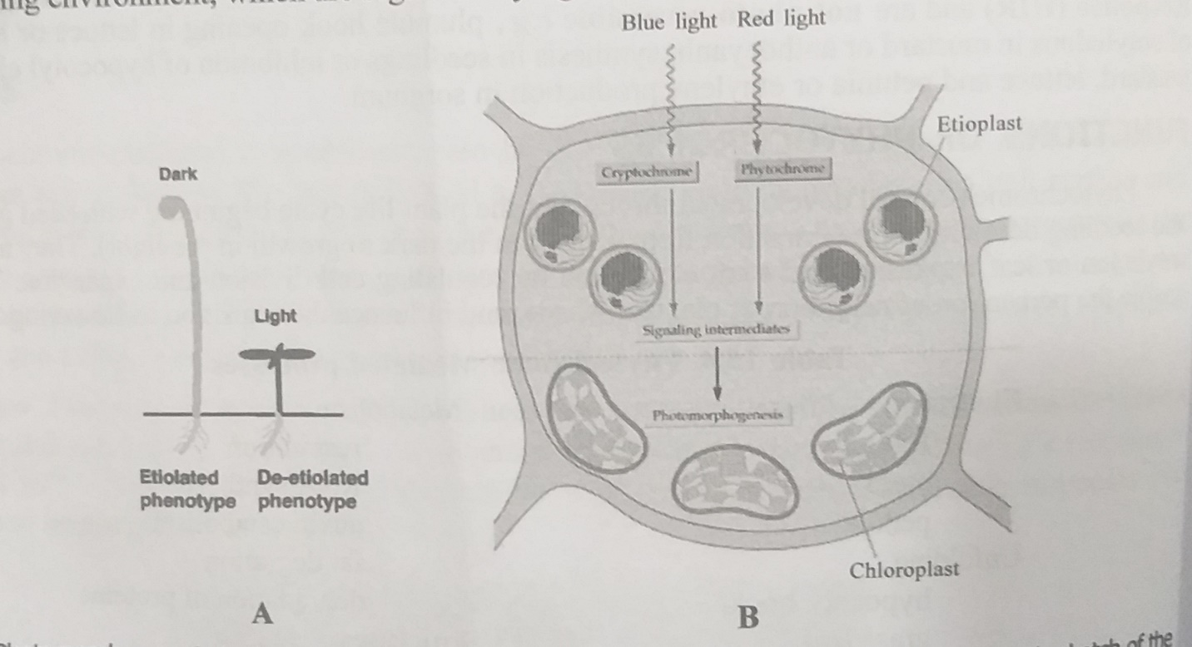
PHOTOMORPHOGENESIS
- CHANGE IN THE FORM OF SEEDLINGS GROWN IN DARK AND LIGHT.
- DIAGRAMMATIC SKETCH OF THE CHANGES IN CHLOROPLAST STRUCTURE.

Some Photomorphogenesis effects of light can be noted easily by comparing seedlings grown in light with those grown in darkness. Large seeds with abundant food reserves eliminate the need for photosynthesis for several days. Dark grown seedlings are etiolated. Several differences caused by light are apparent.
- Chlorophyll production is promoted by light.
- Leaf expansion is promoted by light, but less so in the monocot (maize) than the dicot (bean).
- Stem elongation is inhibited by light in both species (The maize stem is short and will not be visible, because it is surrounded by leaf sheaths that extend nearby to ground level in such young plants).
- Root development is promoted by light in both species.
All these differences seem related to the need of a seedling to extend its stem through the soil if its leaves are to reach the light. More of the food reserves in the endosperm (maize) or cotyledons (bean) are used to extend the stem upward in darkness than in light, and less food is used to develop leaves and roots and to form chlorophyll, all of which are less important for a dark grown plant.
Besides these light effects, many others are essential to monocots, dicots, gymnosperms, and some lower plants. Such effects sometimes begin with seed or spore germination and often culminate in control over flowering. There is a difference between the action of light in causing Photomorphogenesis and in causing photosynthesis. In photosynthesis, light provides all the energy for the process. In Photomorphogenesis, light in low doses sometimes act like a trigger to initiate a developmental process that depends upon photosynthetic products for its completion. So, Photomorphogenetic light initially causes a small change in cells, but this change is somehow amplified greatly so that large morphological events occur. These events vary with the kinds of cells involved, their positions in the plant and their age. Many genes must eventually become activated and other deactivated during Photomorphogenesis.

